Thursday 22nd February 2018
 | 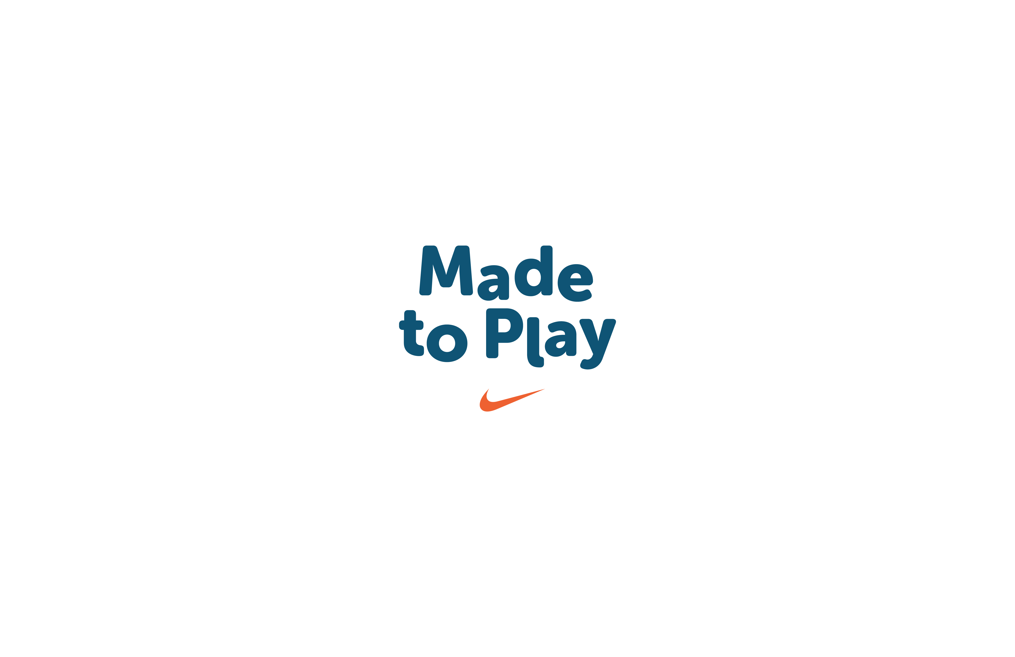
OLYMPIC GOLD MEDALLIST VISITS WANDSWORTH SCHOOL TO INSPIRE PUPILS & TEACHERS TO GET ACTIVE

Pupils at a Wandsworth primary school were inspired to be more active after receiving a special visit this week from an Olympic gold medallist.

Slalom canoeist Joe Clarke, who made history at the 2016 Rio Games by winning GB’s first gold medal in the canoe slalom men’s K1, shared his inspiring story and spent time with pupils at Riversdale Primary School.

The visit was part of a training day of workshops and activities for teachers from across the UK in how to inspire kids to be more active before, during and after school. Organised by Nike and Discovery Education, the event was part of Active Schools Do Better, a new programme to increase kids’ movement and play throughout the school day.

Joe Clarke said:

“It’s a real privilege to be associated with a programme that will have such a positive impact on the lives of so many kids. Sport has given me so much and it’s enriched my life. If we can help and inspire teachers to help kids to get moving, it would be fantastic.”

Jason Dass, a teacher at Riversdale Primary, said

“Our pupils absolutely loved having Olympic medallist Joe Clarke here today. He gave an insight into how he has been inspired and how he hopes to inspire others to follow their dreams and achieve the very best that they can. I think the kids got a lot out of that and they loved seeing his gold medal. The whole idea of Active Kids Do Better is brilliant – the concept of kids always being involved, not necessarily doing sport, but just being more active throughout the school day.”

Fewer than one in four young children in the UK get the recommended amount of exercise*, which means that millions of kids are missing out on the benefit of sport and play. Active kids are healthier, happier and show stronger academic performance.

The Active Kids Do Better programme, developed with the support of Liverpool John Moores University, offers free resources, games and activities to all UK primary schools, and teachers can sign up online at www.activekidsdobetter.co.uk. From short-burst classroom activities to outdoor games and play, the programme gives busy teachers everywhere fun and easy opportunities to get kids moving. They’ll also have the chance to make a special Active Teacher pledge, and to encourage their class to work towards Bronze, Silver and Gold awards.

Active Kids Do Better will also give schools access to Marathon Kids, the nationwide running programme which encourages children to run laps with the goal of achieving four marathons over the course of a school year.

ENDS

*Figures from Public Health England/ Change4Life evidence review on physical activity in children - 2 July 2015.

For further information please contact:

Angie Shatford, PR for Discovery Education: angie@inkstream.co.uk
Mark Hamilton, PR for Nike: mark.hamilton@teneobluerubicon.com

ABOUT NIKE COMMUNITY IMPACT
Nike believes in the power of sport to unleash human potential and build community. We fuel this belief through Made to Play, our commitment to getting kids moving through play and sport so that they can lead healthier, happier and more successful lives. Together with community partners and our employees around the world, we’re designing innovative solutions to get more than 14 million kids playing, running and jumping their way to a brighter future. Find out more about Nike's commitment to getting kids moving and providing opportunities for equal playing fields for all at communityimpact.nike.com.

ABOUT DISCOVERY EDUCATION
Discovery Education empowers teachers and captivates pupils by providing high-quality, dynamic, digital content to primary and secondary schools across the United Kingdom.

Discovery Education offers a range of services and opportunities for schools to meet the needs of students in the digital age. Through its award-winning digital content, interactive lessons, virtual experiences with some of Discovery's most talented presenters and contributors, classroom contests and challenges, professional development and more.

The Discovery Education Community is one of the largest and most active communities of tech-savvy educators passionate about teaching with digital media, sharing resources, collaborating, and networking.

Discovery Education is a division of Discovery Communications, the number one non-fiction media company in the world, which includes the popular global television networks Discovery Channel, Science Channel and Animal Planet.

For more information about the Discovery Education Community and other services and resources, visit www.discoveryeducation.co.uk

About the Physical Activity Exchange, Liverpool John Moores University

The Physical Activity Exchange is part of the world-leading Research Institute for Sport and Exercise Sciences at Liverpool John Moores University. The Exchange is committed to conducting robust scientific research that impacts policy and practice in physical activity, sedentary behaviour and health. For over 20 years, researchers within the Exchange have successfully worked in partnership with local government, public health, industry and the third sector, providing a broad range of research, education and consultancy solutions to support populations to move more and sit less.

